Research Plan for 2024-2034
Version 1 March 2024

The Narragansett Bay Estuary Program (NBEP) was founded to understand how the Narragansett Bay regional estuaries and watersheds change with time, climate, disturbance, and management. NBEP continues to strive for this understanding. This Research Plan will direct limited funds, capacity, and time to priority, gap-filling local research and create a pipeline to new and exciting research and projects which will address the complex questions impacting the region’s water, wildlife, and quality of life. Research may be driven by academic questions, applied research/questions, or concerns directed by local communities. The Plan has two components: (1) response to the Science Advisory Committee priorities to understand ecosystem change and improve freshwater and saltwater habitat, and (2) complement NBEP’s newest Comprehensive and Conservation Management Plan (CCMP), Vision 2034, and engage in opportunistic science.
In Spring 2023, the NBEP Science Advisory Committee (SAC) prioritized the following research activities to understand ecosystem change and improve freshwater and saltwater habitat: (1) synthesize existing data; (2) collect baseline and new data; (3) analysis and modeling; (4) share information widely.
In response, NBEP proposes the Coastal Urban Waters Research Collaborative. This collaboration, comprised of SAC members, researchers, managers, and community experts, will focus on the region’s coastal urban subwatersheds (HUC12) (Providence, Fall River, and Westerly). These urban areas are located at the mouth of the region’s three major rivers, have been subject to intensive management actions to address the intersectional environmental impacts of high population densities and pollution burdens, climate change, and degraded or absent natural landscapes, and are home to many of our region’s underserved communities. Understanding ecosystem change in these areas provides insight for Narragansett Bay, Mount Hope Bay, the Sakonnet River, and Little Narragansett Bay and provide opportunities for improving the habitats surrounding those waters to ensure resilience against climate change and provide more information for current and future management actions. These opportunities will also address the inequities that burden our underserved communities. NBEP chose to limit the geography of its Research Plan to make strategic use of its limited research funds and provide its partners with an opportunity to collaborate on interdisciplinary research to fully understand the human-ecosystem dynamic in select urban estuarine systems.
The Vision 2034 development process identified the need for numeric targets and goals to track action completion. In response, NBEP will use this Research Plan to work with partners to identify those targets and goals, and synthesize or collect the data necessary to fully define those targets. The Program also needs to remain flexible to the changing needs of the region, and therefore will also conduct opportunistic science as necessary.
NBEP will devote approximately 50% of its research budget (averages $50-$100k annually) to meeting the mission of the Research Planand 50% for Vision 2034 target development and opportunistic science. These funds will be released through Requests for Proposals (RFPs), direct awards, and contracts. NBEP will reorganize the Science Advisory Committee (SAC) to include a core group of experts (researchers, managers, and community) in urban watershed research and expand its membership to bring in diverse experts to drive research questions. The SAC will help craft RFPs and/or guide specific research questions that the program can directly award. The Program will also use its Working Groups to continue topical discussions (such as salt marsh or fishermen’s ecological knowledge) and create more working groups as appropriate. NBEP anticipates these experts and partners will respond to the RFPs and be among the experts contacted for direct awards and contracts. Science communication is at the heart of NBEP’s mission. The science generated by this Research Plan will be shared widely in multiple forums to ensure that it is high-quality, available to the public, and integrated into NBEP’s periodic reporting (Status and Trends). NBEP will encourage all partners to publish their work and take ownership of their contributions.

Narragansett Bay Coastal Urban Waters Research Collaborative
During the development of the most recent Status and Trends Report, the State of Narragansett Bay and Its Watershed, and multiple Science Advisory Committee (SAC) meetings, over 100 individual ideas were identified as needing attention in some capacity (Appendix). These ideas included data assessment needs, data gaps to be filled, and research needed to understand a topic. The list is overwhelming and not very useful. The key activities in Figure 1 emerged to organize the list. Even then, it became evident that NBEP alone could not tackle this list for every corner of its region (Narragansett Bay, Little Narragansett Bay, Coastal Salt Ponds, and their watersheds) with its limited budget and staff on a useful timeline. Ultimately, this first Research Plan focusing on coastal urban watersheds is a framework for directing limited funds, capacity, and time to priority and gap-filling, local research to address the complex questions impacting the region’s water, wildlife, and quality of life.
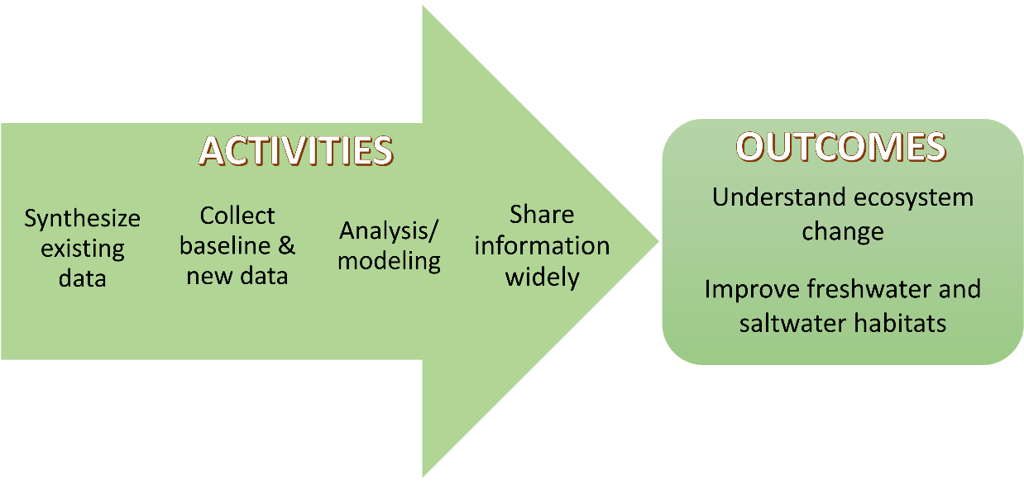
Figure 1. Graphical representation of the Research Plan.
Since its inception, NBEP has funded research projects to explore new issues, synthesize existing data, and create on-the-ground projects to improve fresh and saltwater habitats. This Research Plan represents the first time NBEP has created a guideline to funnel research from questions to answers and create a pipeline to new and exciting research and projects. It is anticipated that one project may contain more than one or all these steps.
The outcomes of the Plan drive research activities, and multiple projects taken together should create significant evidence to show achievement. Research activities and projects include academic topics, applied research, and concerns directed by local communities. The Narragansett Bay region is arguably one of the most studied estuarine regions in the world, with nearly 100 years of research to draw from and datasets available for analysis. The first step along this continuum is understanding and synthesizing the data currently available to shed light on what is known, what is unknown, how the ecosystem is responding to actions, and provide avenues for further, new research. Once the gaps are known, they can be filled through new data collection, and further analysis or modeling. Finally, all information will be shared widely with multiple audiences. These activities can be iterative and non-linear. NBEP anticipates projects will address one or more of the activities listed below.
NBEP Research Plan Activities
Synthesizing Existing Data
The first step will be to synthesize existing data to answer new questions about primary production and food web dynamics, the impacts of climate change, and/or how stormwater and hydrology impact urban areas. During synthesis, we shall ensure that the data currently collected for monitoring is still answering the questions we have and identify new sources of data, if appropriate or needed. Projects could explore uniting multiple types of data, including quantitative (such as chemical, physical, and biological) and qualitative (such as social, survey, or oral history) to understand how people are interacting with nature, the stressor-response relationships in the ecosystem, differentiation of natural versus human impacts, or community-driven questions. Existing historic datasets and archives enable assessment of long-term spatial or temporal trends, or identification of improvements or degradation in the habitat or water quality of the system.
Collecting baseline and new data
Projects will be developed to collect baseline and new data needed to explore new topics or expand/improve upon current projects through data collection for key issues. New topics may include emerging contaminants or marsh migration, while new data for current projects could include new or more efficient ways to collect information on habitat health and/or extent (acreage), aquatic life, or real-time chemical and physical water column information needed to guide decision-making (e.g., continuous sensors or remote sensing).
Analysis/modeling
Fully analyze new data in context with existing data to answer key questions for urban watersheds. Then, use this information and data in existing models to understand complex interactions between hydrodynamics, nutrients, climate, and food webs. If needed, this action will also create models which are open-source and relevant for resource managers to answer critical questions about impacts of sea level and flooding, temperature increases, species migration or other climate change impacts, scenario-planning for further nutrient or stormwater reductions, and/or expansion of commercial fishing throughout urban rivers. Finally, this action could develop mechanisms to discern the consequences of restoration actions for long timescales (10-20 years) to understand the lifetime of management actions in terms of maintenance, retrofits, or abandonment.
Sharing information widely
Each project in this Research Plan will have mechanisms to share key information with relevant audiences, including those outside peer-review. These actions could include white papers, dynamic websites, databases, tools to aid in decision-making, or through mechanisms that make the information digestible for all audiences.
The Narragansett Bay Urban Waters Research Collaborative will empower partners to conduct research to understand ecosystem change in coastal urban watersheds of the region with a secondary goal of improving freshwater and saltwater habitats in the urban waterways. This Collaborative will funnel cross-cutting ideas and expand partnerships to local experts to address key questions the areas need answered (Figure 2).
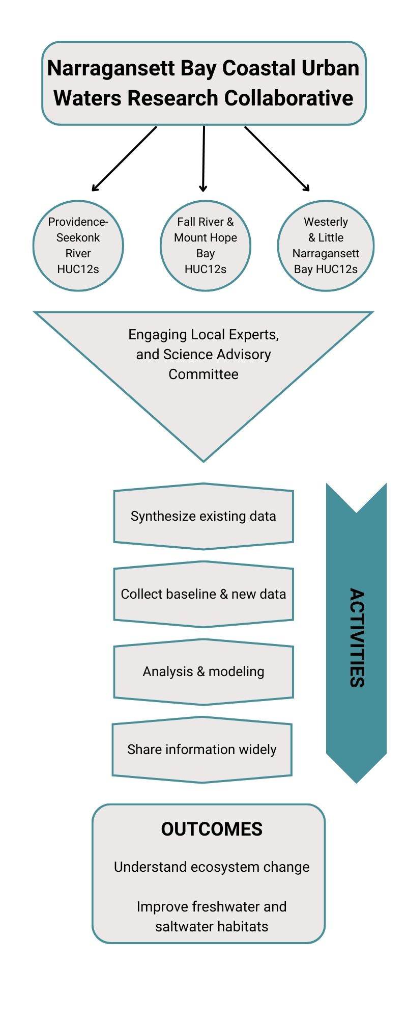
Figure 2. Infographic describing how the Coastal Urban Waters Research Collaborative fits with the activities and outcomes identified by the Science Advisory Committee.
Coastal urban watersheds are defined as the land (HUC12 subwatershed designation) and water located at the mouth of the region’s major rivers with relatively higher population densities compared to neighboring HUC12s. Defined this way, the region’s coastal urban watersheds include the Providence-Seekonk River, Westerly and Little Narragansett Bay, and Fall River/Mount Hope Bay and represent the Blackstone, Taunton, and Wood-Pawcautck Rivers watersheds (Figure 3). These areas are home to over 863,000 people with 45% of the population living in underserved communities that are over-burdened by environmental pollution and lack of access to nature.
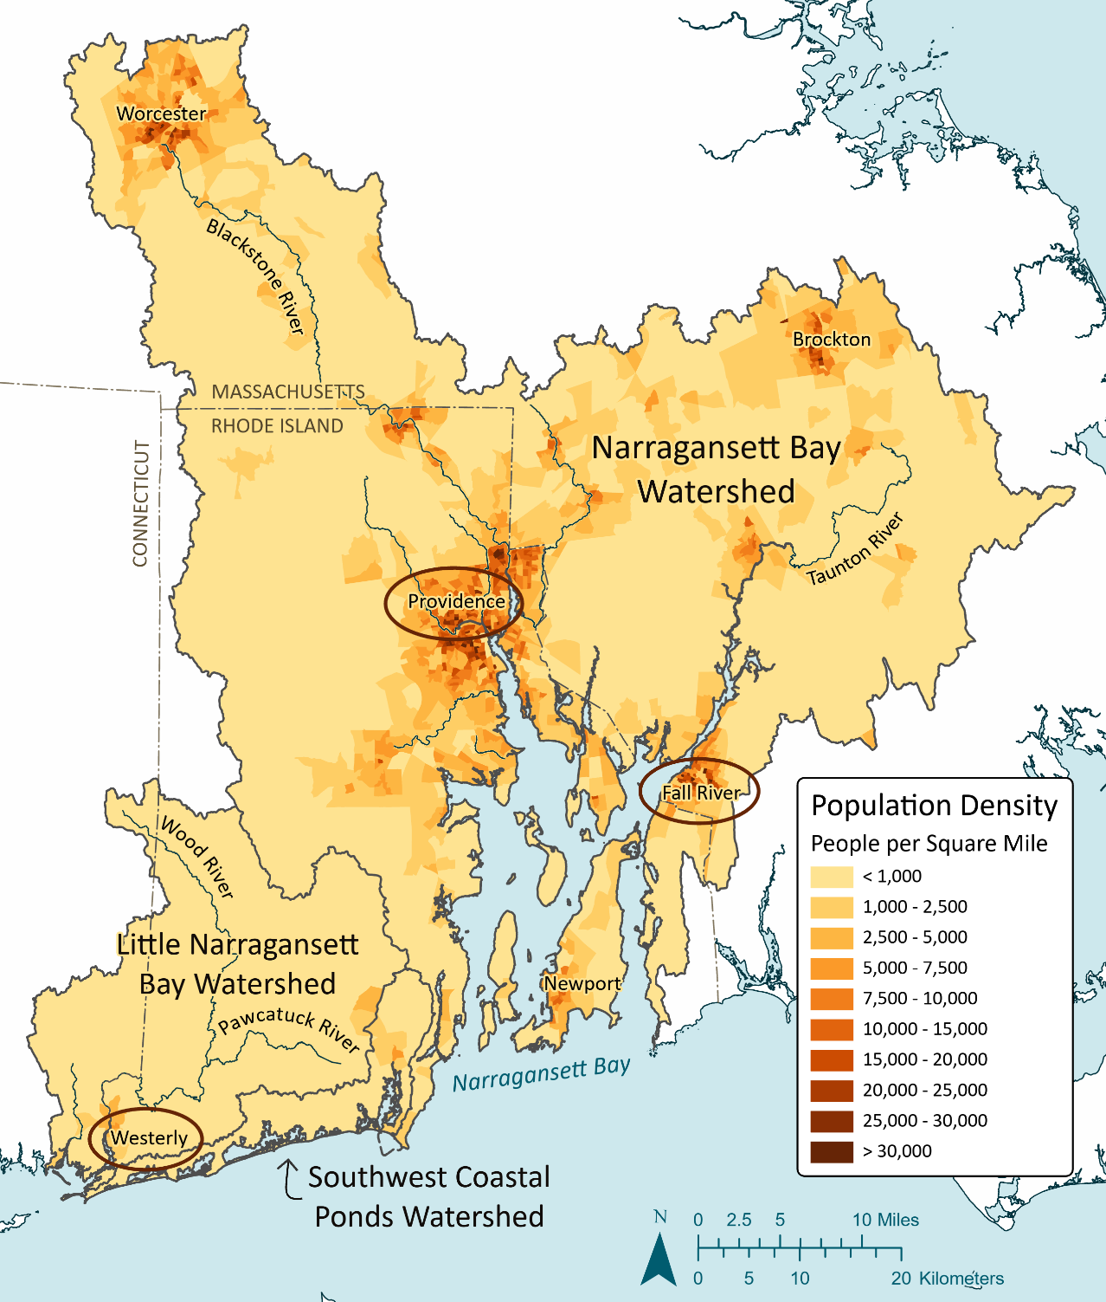
Figure 3. Map of population density for the NBEP Study Areas with Coastal Urban Water geographies circled.
The region’s coastal urban waters are shallow compared to the mainstem of Narragansett Bay or the Atlantic Ocean. Data collected in these regions are usually incorporated into larger works describing the Bay or watershed and not analyzed at a local level. Yet, these are the waters that are the focus of environmental management actions to reduce pollution and protect human health. By analyzing data at a local level, it can be determined how the area is responding to those management actions and if further action is needed. Finally, working towards understanding ecosystem change and improving the ecosystem in the coastal urban watersheds will create positive impacts for those who live and work there, while providing key benefits to waters downstream.
The first Narragansett Bay Coastal Urban Waters Research Collaborative will focus on the Providence-Seekonk River, including all waters and HUC12 subwatersheds in that region (Figure 4). This area is home to over 706,000 people with 46% of the population living in underserved communities and has been the target of many management initiatives or interventions, including reducing heavy metals, nitrogen, and bacteria through better wastewater and stormwater management, and improving the coastline through habitat restoration. Among the realized and desired outcomes of those initiatives are an urban beach initiative, opening of the lower Providence River and Mount Hope Bay to shellfish harvesting, fish passage through the lower four dams of the Blackstone River, and habitat restoration along the Woonasquatucket River. Consequently, many monitoring projects and individual projects have occurred here, creating a large repository of data to synthesize and inspire new projects, especially those that combine social and biophysical science or incorporate monitoring of new restoration, protection, or access projects.
After the initial focus on the Providence-Seekonk River, the Narragansett Bay Coastal Urban Waters Research Collaborative will shift its focus to other coastal urban watershed hubs in the region, namely Fall River (Taunton River, Mount Hope Bay) and Westerly (Pawcatuck River, Little Narragansett Bay) (Figure 4). Fall River and Mount Hope Bay have over 118,000 people with 47% of the population living in underserved communities. Westerly and Little Narragansett Bay have over 38,000 people with 17% of the population living in underserved communities. The transition to these new geographies will occur through our experts finding consensus, achieving our objectives, and encouraging external funding by leveraging NBEP’s research dollars into larger projects. In these areas, we will once again begin by synthesizing existing information and creating projects to best answer the questions that remain.

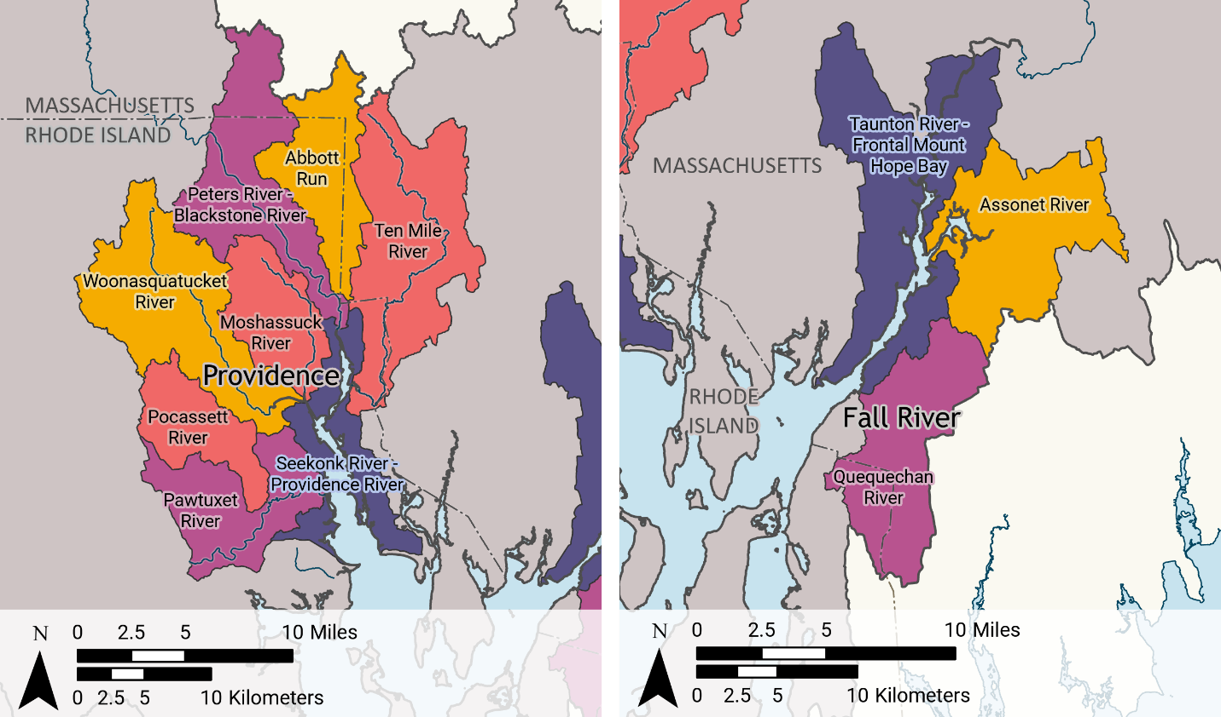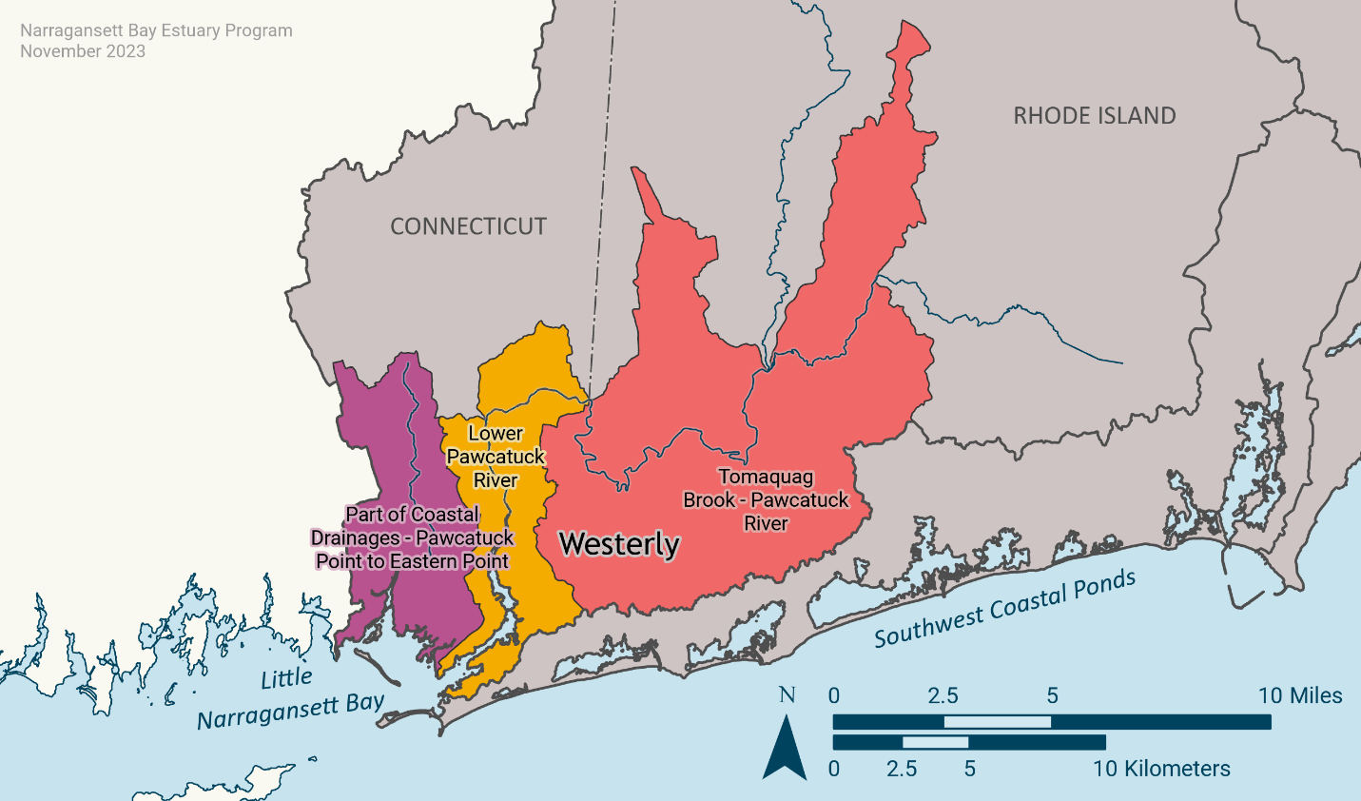
Figure 4. Waters and Subwatersheds (HUC12s) for the three study areas: Providence (top left), Fall River (top left) and Westerly (lower).

Vision 2034 Target Development and Opportunistic Science
Vision 2034 is NBEP’s most recent comprehensive and conservation management plan (CCMP). The Research Plan is designed to meet the needs of Vision 2034 and unite the scientific interests of the partnership under one plan. Specifically, this Research Plan will address the following actions:
- Develop and update indicators of environmental and socioeconomic conditions
- Support, improve, and create efficiencies for ecosystem monitoring efforts
- Gather and practice cultural ecological knowledge
- Create model(s) needed to answer complex questions and improve ecosystem management
- Share scientific concepts using visualizations, storytelling, and decision-support tools
- Create shared goals with number targets that span boundaries
Indirectly, this plan will aid in data synthesis, collection, and analysis to support actions to
- Reduce pollution from wastewater discharges,
- Improve resilience to sea level rise and flooding,
- Restore and improve the resilience of estuarine and coastal habitats,
- Restore the connectivity and function of freshwater systems,
- Protect and restore upland habitats,
- Equitably and responsibly increase the number of public access points to the region’s natural resources, and
- Ensure safe, quality access to natural resources in the region.
NBEP must also remain flexible and responsive to the changing needs of the partnership. The exploration of the coastal urban watersheds or targets for Vision 2034 may open avenues of research and science yet to be considered. Therefore, NBEP believes it important to identify opportunistic science as part of its research plan.

Implementing the Research Plan
The Research Plan stemmed from an effort to identify gaps discovered while completing the most recent Status and Trends Report (State of Narragansett Bay and Its Watershed). Many of the questions remain unanswered and are still relevant to the work NBEP and its partners do. Going forward, we will use the Research Plan and Vision 2034 to identify the key indicators that need frequent reporting, and indicators that can be reported on infrequently.
Combined Vision 2034, the Research Plan, and the Status and Trends Report will tell the “story” of the region, through the lens of what we need to do (Vision 2034), what research or science is needed to complete the actions listed in Vision 2034 (the Research Plan), and finally, how do we track progress towards goals, and add convey the story of the region (science updates and the State of the Study Area).
The Research Plan will be implemented across NBEP’s core services – funding, convening, and communicating science. Each core service area lists NBEP’s anticipated actions and expected accomplishments.

Funding
NBEP anticipates approximately $50,000-$100,000 per year from NBEP’s annual workplan and budget to be devoted to fulfilling scientific research needs. These amounts are not guaranteed, as the budget and needs of the Program may change. If necessary, NBEP will combine funds from multiple fiscal years to make more funding available at a time.
Over the next 10 years, NBEP will generally divide its science funding into two segments: (1) Narragansett Bay Coastal Urban Waters Research Collaborative (50%) and (2) Vision 2034 Target Development and Opportunistic Science (50%). These percentages are guideposts to ensure that NBEP is meeting the objectives of this Research Plan while remaining flexible to tackle challenges that may arise. Over the 10 years of this plan, NBEP hopes to award approximately $500,000 to $1 million towards research, which translates to $250,000 to $500,000 towards the Narragansett Bay Coastal Urban Waters Research Collaborative (across the three geographies) and $250,000 to $500,000 towards Vision 2034 target development and opportunistic science.
NBEP will award research funds in three ways: Requests for Proposals (RFPs), direct awards (non-competitive), and contract services. RFPs will be used when NBEP wants to see a variety of ideas in response to a particular topic. Direct awards or contract services will be used when NBEP wants a particular topic or question addressed and knows the expertise needed. RFPs will be reviewed by NBEP’s ad hoc grants review committee, with members chosen for their expertise on the RFP topic.
NBEP recognizes that while significant, this level of investment cannot fulfill the goals of the Research Plan. As outreach and partnership identification and inclusion in the Research Plan increases, partners who have the capacity to self-fund or issue RFPs may take on mission-relevant activities to answer the work actions in this Research Plan. NBEP will conduct outreach at local colleges and universities to explore how they could partner in funding this plan. NBEP also plans to work with other funders to release joint RFPs, and create a quasi-funders network to coordinate efforts. These funders could include RI Science and Technology Advisory Council (STAC), RI Sea Grant, CT Sea Grant, and the Southeast New England Program (here and here). Additionally, avenues of coordination could be explored with the states’ nonpoint source grants (Clean Water Act Sections 319 and 604b), priority project programs, and water quality monitoring grants. This level of coordination will increase the amount of funding available for research in the region and enable NBEP to expand its Coastal Urban Rivers Research Collaborations to the Westerly/Little Narragansett Bay and Fall River/Mount Hope Bay sooner than anticipated. It will also increase the amount of funds NBEP has available for Vision 2034 target development and opportunistic science occurring throughout the region.
NBEP will continue to expand the list of funders in the region to create an unofficial funder’s network to support the Plan.

Convening
NBEP convenes experts to discuss the science of the region in two main ways: the Science Advisory Committee and Working Groups. These committees and groups help NBEP connect with other experts in the areas and fields of interest. NBEP staff will coordinate and convene these experts to address both the Narragansett Bay Coastal Urban Waters Research, Vision 2034 target development, and opportunistic science that arises. It is expected that these experts will help NBEP develop targets and goals to guide and/or track actions and leverage their networks to improve NBEP’s expertise on an issue. These groups also provide NBEP with the needed ideas for RFPs, direct awards, or contracts to address this Research Plan.

The Science Advisory Committee
The Science Advisory Committee (SAC) guides NBEP’s scientific programs, provides expertise on key issues, and is heavily involved with the periodic State of the Study Area status and trends reports. Traditionally, the SAC has been composed of 15-16 members from the scientific research, management, and advocacy sectors and are experts in the topics covered by the status and trends report (climate change, landscape stressors, pollutants, the bay ecosystem, the watershed ecosystem, and aspects of public health associated with beaches and shellfishing). The SAC meets three times a year.
NBEP plans to re-organize its SAC to meet the needs of the Research Plan and become larger in the process (Figure 5). The SAC will have a “core” group of 5-6 members with the geographic and topical expertise needed to address the Plan, and a willingness to support NBEP between SAC meetings. The “core” group will self-identify or be chosen by NBEP for their expertise. The remainder of the SAC will become a network of management, research, and community experts who will be asked to weigh in on specific topics relevant to their expertise. NBEP plans to expand the SAC to include more members with social science and public health backgrounds or are community leaders to address the complex and interdisciplinary needs of the region. The SAC will likely meet three times a year, with one of those meetings being used as a symposium to discuss the progress made on fulfilling the Research Plan the year prior.
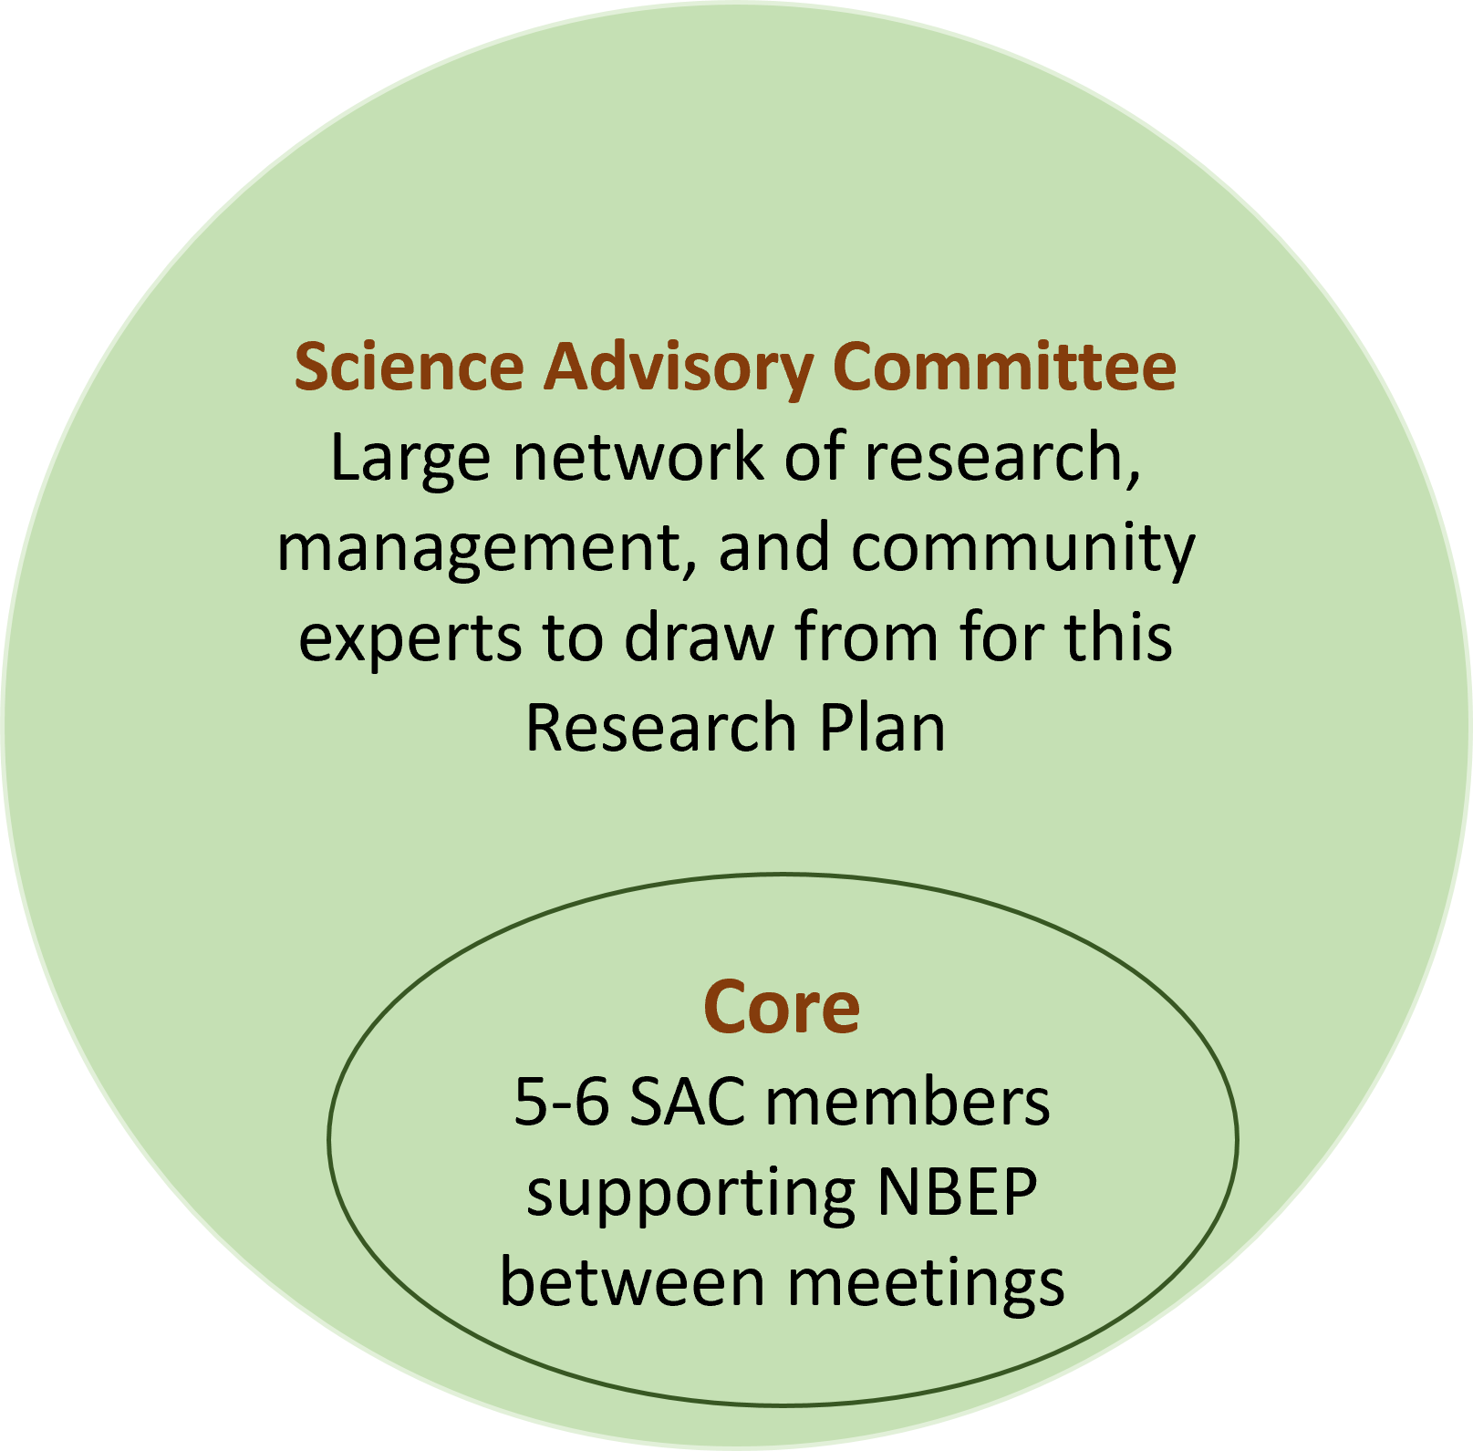
Figure 5. Visualization of the Science Advisory Committee

Working Groups
NBEP maintains working groups to address topical issues outside of the SAC. These working groups range from structured programs to ad hoc groups to address a pressing need in the watershed. The current working groups are: Saltmarsh Restoration, Assessment, and Monitoring Program (RAMP), Fishermen’s Ecological Knowledge, Subaquatic Vegetation (SAV), Social Science, and Water Clarity. NBEP will create working groups at the request of its partners or when staff notice a need to discuss a particular topic. These groups have key knowledge that will advance the Research Plan and NBEP will convene meetings to discuss topics, questions, or other issues that arise during the execution of the Plan. Working groups meet when necessary, with more active groups meeting monthly for a short period of time, or seasonally to discuss new topics.

Other Experts
NBEP will expand its partnerships with those who are not currently represented on the Science Advisory Committee or working groups. This could include deeper engagement with Rhode Island’s Department of Environmental Management (Division of Marine Fisheries or Division of Forestry), Department of Health, Massachusetts’ Division of Ecological Restoration, Division of Marine Fisheries, or Department of Public Health. NBEP will also establish new partnerships, such as with the NOAA Marine Fisheries Service Narragansett Lab, USEPA’s Urban Waters and Trash-Free Waters Programs, or local watershed or community groups and tribal nations operating within the urban watersheds.
The region has experts who have developed Research Plans, lists of needs, or are currently restoring or revitalizing their areas. The Massachusetts Ecosystem Climate Adaptation Network’s Salt Marsh Working Group documented priority research for saltmarshes. The Long Island Sound Study maintains a needs document with information on how well these needs are being identified. Finally, Humphries and colleagues published a review of modeling and related science needs for Narragansett Bay. Throughout the region, restoration and revitalization is occurring. Within the our coastal urban watersheds the Saltmarsh RAMP is developing a master website of all projects, Mass Audubon has restructured their coastal restoration group, Westerly is poised to revitalize the entire riverfront, and Fall River is establishing a resiliency district. These organizations and places are excellent places to look for collaborations or improve upon the ideas developed through this Plan.
The potential funders listed above are also experts to be tapped for the region and will be included in outreach. The partners, Research Plans, and funders listed here are not exhaustive. NBEP will continue to update this list as more partners, plans, and funders are identified.

Communicating Science
The final activity in the Research Plan pipeline is to share information widely, which can take many forms. In addition to funding partners to share information, NBEP anticipates communicating the science learned during this Plan in the following ways:
- Make all meeting agendas and notes publicly available;
- Create science updates to existing indicators (see NBEP’s science page);
- Develop new indicators (see Tracking Success below);
- Create tools to aid decision making at all levels;
- Create Vision 2034 numeric targets and goals
- Host webinars
- Deliver or contribute to conference presentations
- Host events, such as the NBEP Annual Science Event, to share information related to the Research Plan
- Release annual updates on the Research Plan highlighting how the plan is meeting its goals (see Tracking Success below);
- Encourage subawardees, the SAC, working groups, and other partners to publish their research in peer-reviewed journals.
Any data that is developed from the Research Plan will be made publicly available through NBEP’s Figshare, data hub, or a partner’s websites.

Timeline for Implementation
The timeline below describes the goals for the Research Plan, a potential transition to the next Comprehensive and Conservation Management Plan (CCMP) that NBEP will develop in 2034 (Year 10), and what that transition will look like in Year 15 (Figure 6). Decisions to transition to new geographies or sunset work on a current geography will be by consensus, through achieving objectives, and encouraging external funding.

First Actions: Years 1-2
During Years 1-2 of the Research Plan, NBEP (staff and interns) will conduct a literature review of the three coastal urban watershed hub geographies starting with Providence-Seekonk Rivers. The literature reviews will ensure that all work taken on by NBEP, its SAC, and partners under the Narragansett Bay Coastal Urban Waters Research Collaborative will be additive. NBEP will also convene the SAC and connect with others to identify any additional experts needed to tackle this Research Plan. Collectively, these actions will also help NBEP identify any gaps in knowledge, data needing synthesis, or topics of interest that should be explored further. NBEP will also work with the SAC to develop a Request for Proposal (RFP) focused on synthesizing existing data. The intention of the RFP is to begin building the pipeline to new data collection, analysis, and modeling, and sharing information widely. By examining existing data, we can look for gaps and identify questions about ecosystem change and habitat improvement.

Summary of Activities
This Plan is designed to last approximately 10 years with key checkpoints along the way. First, this plan will be revisited regularly, approximately every year or two. By the halfway point, the Collaborative should be exploring a second urban river watershed. The Plan should have been revisited a couple times, and NBP should have supported work through 2 RFPs and/or direct awards. By the 10-year mark, research at two of the coastal urban river watersheds should be self-sustaining or sunsetting, and work should be happening in the third coastal urban river watershed. An additional 2 RFPs or direct awards should have been released, and discussions about how the outputs from the Plan will inform the next CCMP and State of the Study Area report.
The SAC will meet to gain consensus on moving forward to another coastal urban river watershed. This decision could be steered by the number of outputs, the types of questions researched or answered, and general desire to move to a new geography and share the best practices. The timeline is only here to help the SAC move forward, and is subject to change based on needs of NBEP, the SAC, and availability of money and capacity.
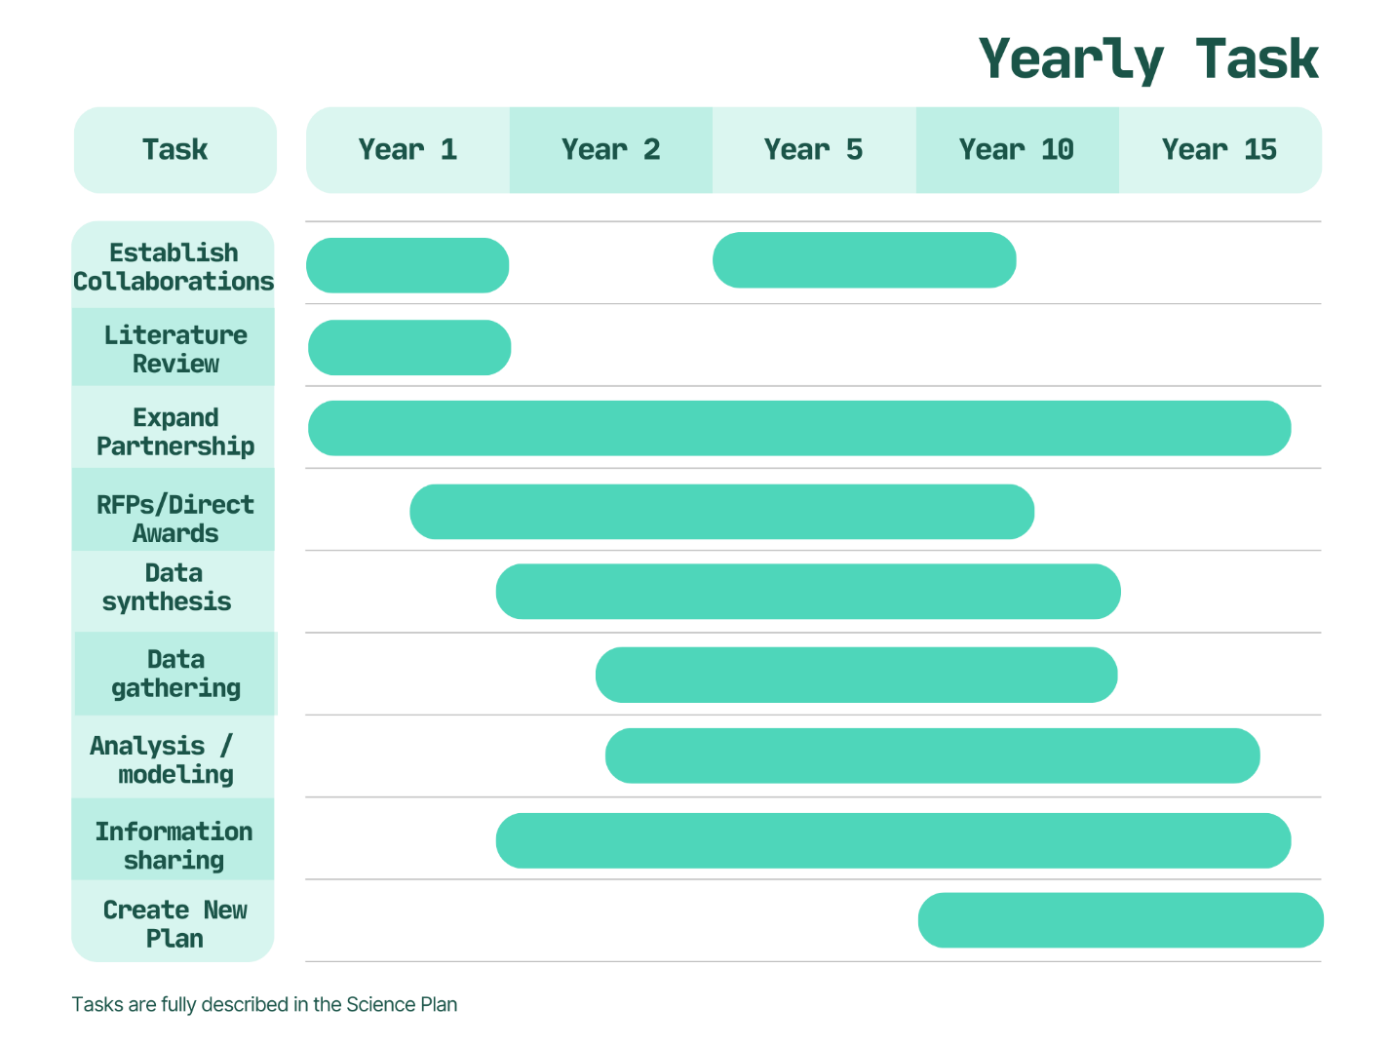
Figure 6. Timeline for Implementation of the Research Plan

Tracking Success

Defining Success
Success of this Research Plan is meeting some, if not all, of the work defined above for the coastal urban watersheds and developing shared, research-based, numeric targets for Vision 2034. Pursuing opportunistic science is not necessary for success, however, funded opportunistic projects should be well-documented. Deliverables from this Research Plan include detailing the environmental and restoration success stories for the region, particularly in the coastal urban watersheds, creating clean avenues to continue improvement while addressing user conflicts, and developing Vision 2034 numeric targets with appropriate monitoring. This story will also include broadening partnerships with experts in all avenues of science, management, advocacy, and community organizations.
Prior to this plan, NBEP’s CCMP and Status and Trends Report (most recently, State of Narragansett Bay and Its Watershed) were not developed or implemented in coordination with each other. These documents also did not fully cover the environmental and socioeconomic challenges of the Study Area, instead focusing mostly on the environmental issues in Narragansett Bay. The Status and Trends Report did not always track how the partnership met the goals outlined in the CCMP. Integrating and expanding the geographic reach of these plans with other National Estuary Program required plans (including research, monitoring, habitat restoration, finance, and engagement) would create better coordination across the partnership united under one vision and mission. This integration would encourage the creation, updating, and monitoring of environmental and socioeconomic indicators and targets and allow NBEP to report fully on progress.

Indicators & Metrics
NBEP will endeavor to track success over time through two avenues: (1) how well NBEP and its partners implement the Research Plan and (2) how well individual projects meet/achieve the outcomes of the Research Plan.
Currently, NBEP uses 24 environmental indicators that describe the stressors to the region (such as population growth, nutrient loading, land use, and chemical pollutants) and associated environmental conditions. The condition indicators describe how the environment responds to these stressor indicators. Indicators are topics that allow NBEP to evaluate key stressors to the region, assess condition, describe trends, and look ahead towards potential future changes. Metrics are specific subtopics and associated data that inform the full indicator. NBEP uses metrics to evaluate the trends and provide information for future changes.
The metrics used to track how well the Research Plan is implemented are organized by NBEP’s core services:
- Funding
  - Number of RFPs released or contracts/direct awards given which address topics/issues/projects developed in this plan;
  - Dollar amount awarded through RFPs or direct awards or contracts;
- Convening
  - Number of Science Advisory Committee meetings and number of attendees (including notes), and key information about attendees (organization, diversity metrics, etc.)
  - Number of topical work groups created/continued and number of attendees (including notes) and key information about attendees (organization, diversity metrics, etc.);
  - Number of meetings with experts outside of the SAC and Working Groups
- Science Communications
  - Number of deliverables such as journal articles, science updates, white papers, digital media (websites, story maps), etc.;
  - Number of indicators developed or refined;
  - Number of webinars or events derived from research funded by the Research Plan (including summaries, notes, and number of attendees); information about the webinars including target audience (researchers, managers, public, advocates, etc.)
  - Number of conference presentations

outcomes
This plan has two anticipated outcomes: (1) understand how the ecosystem has changed in the urban watersheds to natural and human disturbance; and (2) improve the freshwater and saltwater habitats of our urban waterways. Methods for measuring the outcomes of the individual projects completed under this Research Plan must be carefully considered. Ideally, the outcomes of the projects completed under this Research Plan will align with the indicators and metrics NBEP developed for its Status and Trends Report, such that those metrics can track project outcomes and Research Plan implementation. If necessary, NBEP will work with partners to create new indicators and metrics to measure the outcomes of the individual projects and the Research Plan as a whole.

About NBEP
The Narragansett Bay Estuary Program (NBEP) is one of 28 place-based National Estuary Programs, first established in 1987 by an amendment to the federal Clean Water Act, overseen by the U.S. Environmental Protection Agency. The estuary program uses a voluntary, community-driven approach to enhance water quality, wildlife, and quality of life across our study area, which includes the Narragansett Bay, Little Narragansett Bay, Coastal Ponds, and their watersheds in Rhode Island, Massachusetts, and Connecticut. The Narragansett Bay Estuary Program is hosted by the Community Partnerships Center at Roger Williams University.

NBEP is planning on releasing a new Status and Trends Report, tentatively named State of the Study Area, to encompass NBEP’s entire region: Narragansett Bay, Little Narragansett Bay, the Coastal Ponds and their watersheds.

